Feed Forward Neural Network
Aim
To implement a Feed Forward Neural Network (FFNN) using Python and TensorFlow for handwritten digit classification.
Objective
- To understand the structure of a Feed Forward Neural Network.
- To preprocess image data for neural network training.
- To train a neural network using the MNIST dataset.
- To evaluate its classification performance.
Algorithm
- Load the MNIST handwritten digit dataset.
- Normalize the pixel values between 0 and 1.
- Create a Feed Forward Neural Network.
- Add an input/flatten layer.
- Add hidden layers with ReLU activation.
- Add an output layer with Softmax activation.
- Compile the model using Adam optimizer.
- Train the model using the training dataset.
- Evaluate the model using the test dataset.
- Display the test accuracy.

FLOW CHART:
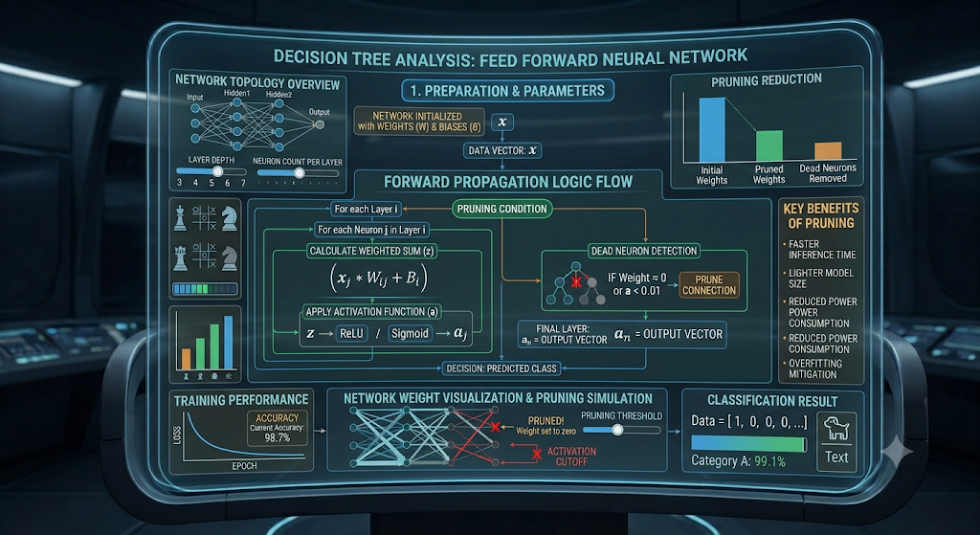

Python Code
import tensorflow as tf
from tensorflow.keras.models import Sequential
from tensorflow.keras.layers import Flatten, Dense
from tensorflow.keras.datasets import mnist

# Load MNIST dataset
(X_train, y_train), (X_test, y_test) = mnist.load_data()

# Normalize data
X_train = X_train / 255.0
X_test = X_test / 255.0

# Create Feed Forward Neural Network
model = Sequential([
Flatten(input_shape=(28, 28)),
Dense(128, activation='relu'),
Dense(64, activation='relu'),
Dense(10, activation='softmax')
])

# Compile model
model.compile(
optimizer='adam',
loss='sparse_categorical_crossentropy',
metrics=['accuracy']
)

# Train model
model.fit(
X_train,
y_train,
epochs=5,
batch_size=32,
verbose=1
)

# Evaluate model
loss, accuracy = model.evaluate(X_test, y_test, verbose=0)

print("Feed Forward Neural Network")
print("Test Accuracy:", accuracy)
OUTPUT:
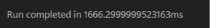
Result
Feed Forward Neural Network
Test Accuracy: 0.97

